**M5StickC Lab Report**

The purpose of this lab report is to document how I would have used the M5StickC during this class time and to see if I was able to properly manipulate the device as requested. For this lab, there were two main objectives: to run the hello world sketch then the RTC sketch in the Arduino software to display on the M5StickC.

**M5StickC Resources**

## Specification

| **Resources** | **Parameter** |
| --- | --- |
| ESP32 | 240MHz dual core, 600 DMIPS, 520KB SRAM, Wi-Fi |
| Flash Memory | 4MB |
| Power Input | 5V @ 500mA |
| Port | TypeC x 1, GROVE(I2C+I/0+UART) x 1 |
| LCD screen | 1.14 inch, 135*240 Colorful TFT LCD, ST7789v2 |
| Button | Custom button x 2 |
| LED | RED LED |
| MEMS | MPU6886 |
| Buzzer | built-in buzzer |
| IR | Infrared transmission |
| MIC | SPM1423 |
| RTC | BM8563 |
| PMU | AXP192 |
| Battery | 120 mAh @ 3.7V |
| Antenna | 2.4G 3D Antenna |
| PIN port | G0, G25/G36, G26, G32, G33 |
| Operating Temperature | 0°C to 60°C |
| Net weight | 15g |
| Gross weight | 21g |
| Product Size | 48.2*25.5*13.7mm |
| Package Size | 65*25*15mm |
| Case Material | Plastic ( PC ) |

**Hello World Sketch**

After connecting my M5StickC and launching the Arduino 2.0.3 software, I ran the “Hello World” sketch.

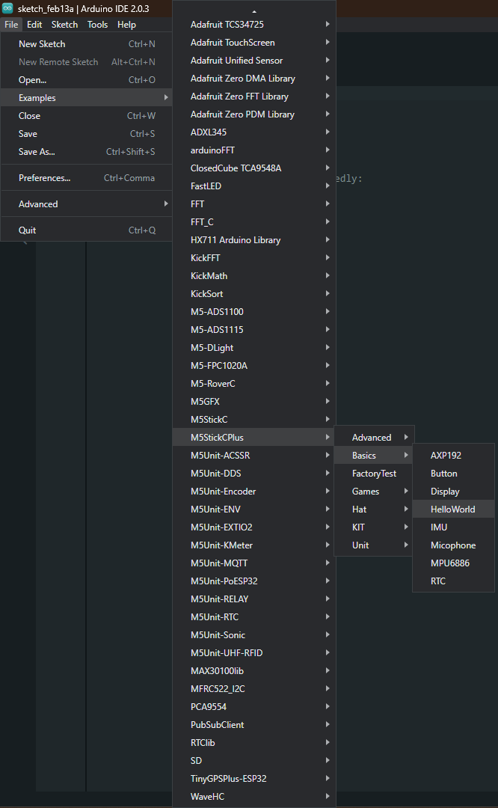

After starting the sketch, I set the background to white and changed the text size to 2 instead of 3. I did this using the following code:

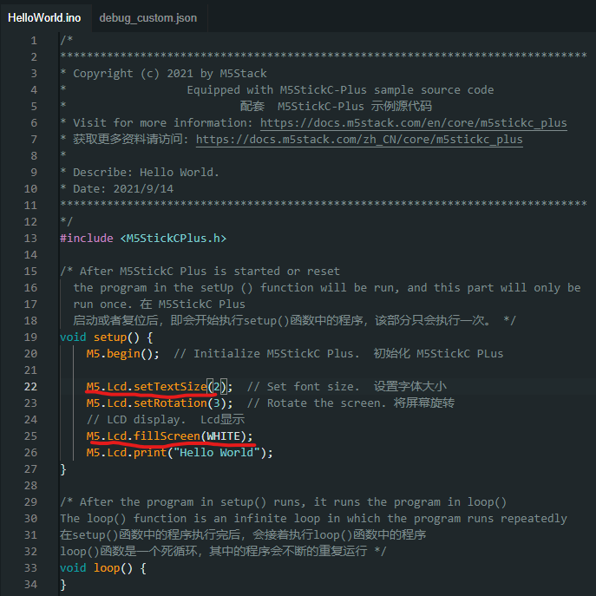

Next, I changed the “Hello World” to my first and last name and kept the rotation at 3 so that it can display horizontally. I did that using this code:

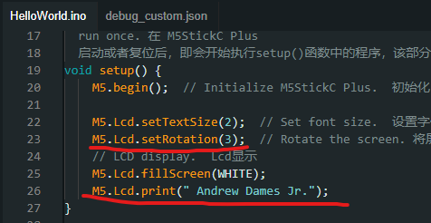

Finally, for this part of the lab I changed the text to black so that the black border would be removed from around the white text. Here’s the final sketch and results:

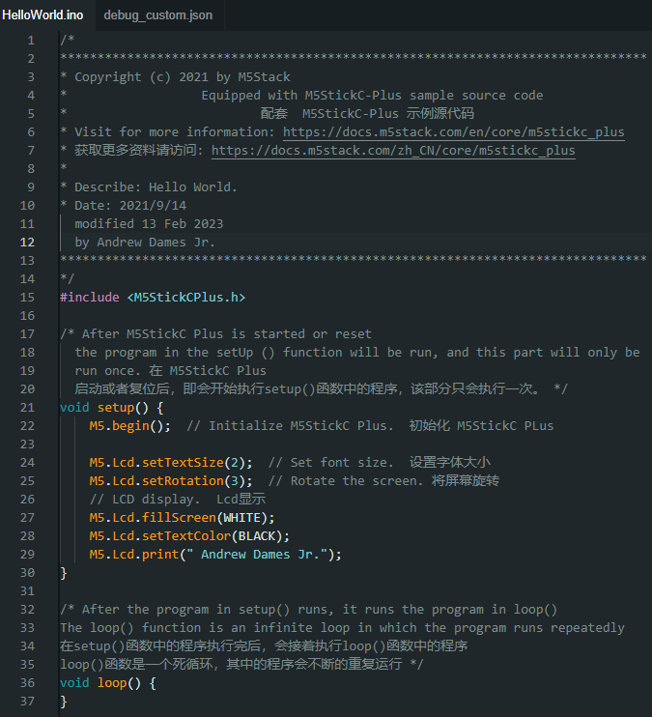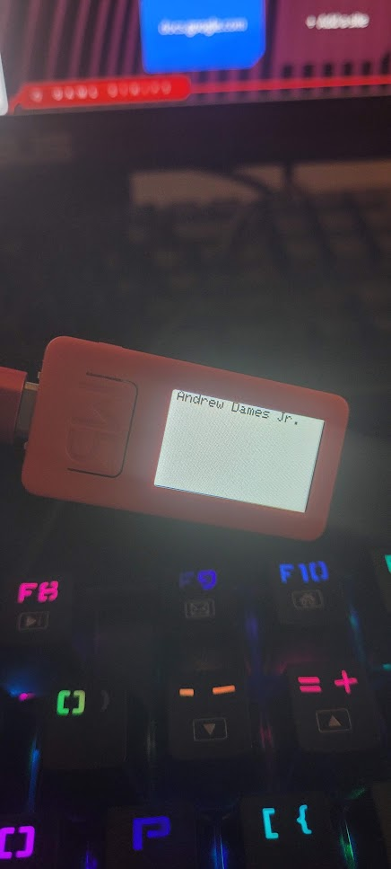

**Real Time Clock (RTC) Sketch**

To start this part of the lab, I loaded the RTC sketch and ran it. The sketch compiled and worked fine so I moved on to editing the sketch. The first thing I did was correct the date and time in the code. This was done using this code:

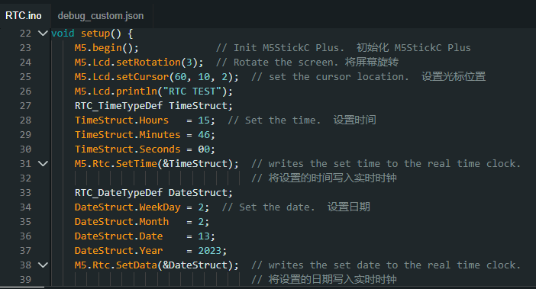

To finally complete this part of the lab I now had to combine the two sets of code. This posed a problem for me immediately as the text seemed to appear inside of the clock. I noticed that whenever the screen was white and the text was black it caused the seconds part of the clock to stop working. However, if I left the text white and made the screen black, the code worked perfectly fine. Here’s the final product:

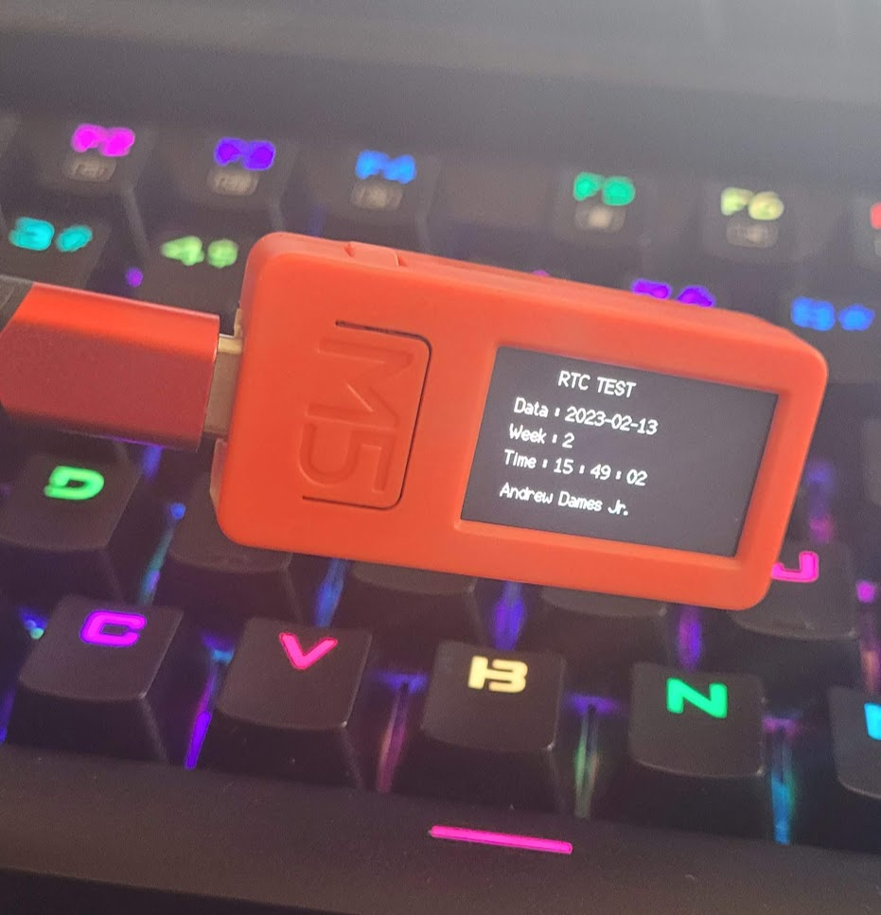

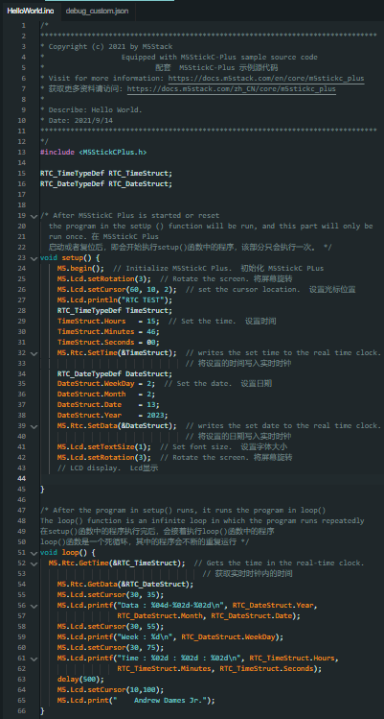

**Implementation**

* + For this lab, I used the following items:
    - A computer
    - The M5StickC
    - A usb-c cable
    - The Arduino 2.0.3 software
    - Here’s the full video demonstration of the coding process and uploading it to the device: <https://youtu.be/zwroxTvsaQc>
  + **Source Code**
    - 
  + Structure explanation
    - Line13: This line specifies the device from the library we’re using.
    - Line 23: This initiates the setup of the process (makes the function run once when the board is powered on) with the “void setup () {}” command.
    - line 24: Tells the device where the code begins.
    - Line 25: This line sets the device to a horizontal display having the M5 button on the left side of what would now be considered upright.
    - Line 26: This tells the devices where to start and stop displaying whatever you put on the LCD screen. Think of this as a border.
    - Line 27: This prints the words “RTC Test” on the screen.
    - Lines 28-32: This sets up the time to display on the screen.
    - Lines 34-39: This sets up the date to display on the screen.
    - Line 41: Sets the text size of the font that will appear on the screen.
    - Line 51: Initiates the loop functions.
    - Lines 52-62: These lines call the date and time functions then set up the timer to start from where you set it until however long the screen is on.
    - Line 63: A delay before we display the text.
    - Line 64: Sets where we want the name to appear on the screen.
    - Line 65: Writes my name on the screen.
  + This lab didn’t require any calculations.